How to extend your wireless work by button
Product line: Wireless Model number: A300/A301

By pressing the EXTENDER button, we can achieve wireless bridging for extending wireless network without complicated procedure .This feature will only be effective in range extender mode. Steps are as
follow. Before setting A300, please make sure that you can get internet if you connect your computer to upper router directly.

- Press the WPS of your wireless router for 1-3 seconds，its WPS light should be blinking. If the WPS light of upper router does not come out ，please login router homepage to enable it manually.
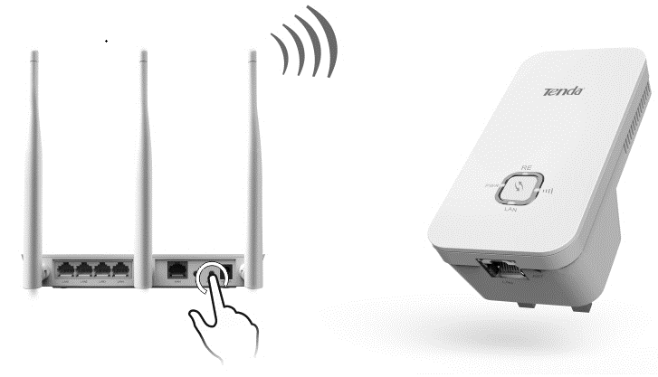
2. Press the RE button (  ) on the wireless range extender twice quickly in one second.
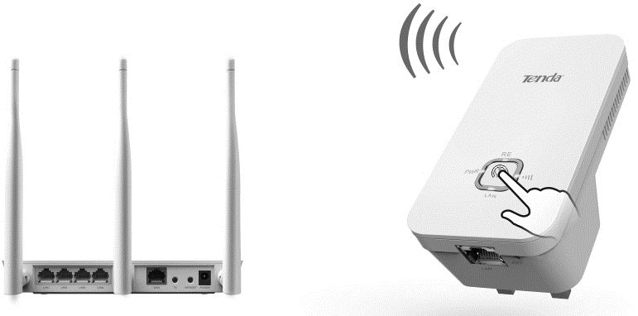
- When the RE LED displays a solid light, the wireless range extender will be connected to your desired router successfully. You can also login to the web management interface to check bridge status.
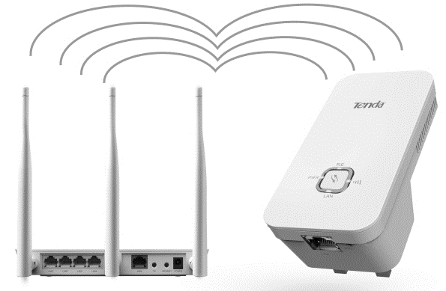

Note： Our Range extender can only work fine with those routers which can support the standard of WPS 2.0. If you failed to bridge your wireless network by pressing the button of A300/A302,we recommend you to set the wireless network mode of upper router as WPA2-PSK or mixed WPA2-PSK/WPA-PSK or extend your wireless via management page.

How to extend your wireless network via management page

